**NAAN MUDHALVAN REPORT**

**ON**

**DIGITAL MARKETING**



***Submitted By***

## ANUJA.S (724020121005)

***in partial fulfillment for the award***

***of the degree***

***of***

## BACHELOR OF ENGINEERING

**IN**

## BIOMEDICAL ENGINEERING

**DHAANISH AHMED INSTITUTE OF TECHNOLOGY,**

**COIMBATORE**

**ANNA UNIVERSITY::CHENNAI 600 025**

**NOV/ DEC 2023**

## BONAFIDE CERTIFICATE

Certified that this Naan Mudhalvan report on “**Digital Marketing**” is a bonafide work of “**ANUJA.S (724020121005)**” and had carried out this **Naan Mudhalvan Training** under my supervision.

## SIGNATURE SIGNATURE

**R.PRAKASH Dr.N.APARNA**

FACULTY IN-CHARGE HEAD OF THE DEPARTMENT

Assistant Professor Associate Professor

Department of Food Technology Department of Biomedical Engineering

Dhaanish Ahmed Institute of Dhaanish Ahmed Institute of

Technology, Technology,

Coimbatore-641 105 Coimbatore-641 105

# Submitted for the Digital Marketing Course for Naan Mudhalvan Scheme held during the month of _______________ at Dhaanish Ahmed Institute of Technology, Coimbatore.

# Principal

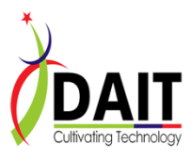

## 

**COURSE NAME** : Naan Muthalvan –Digital Marketing  
**GROUP NUMBER:** 02

**PROJECT TITLE:** How to create brand name ,logo and brand mail-id using CANVA

**PROJECT SUBMITTED TO:** Anna University / Naan Mudhalvan

**YEAR:** IV Year

**DEPARTMENT:** Biomedical Engineering

**SEMESTER:** VII

**GROUP MEMBERS:** ANUJA.S

JAISRI.B

MONISHA.S

THENMOZHI.Y

**GUIDED BY:** Prakash.R AP/FT

**SPOC NAME:** Mr.Nandhakumar AP/ECE

**TABLE OF CONTENTS**

|  |  |  |
| --- | --- | --- |
| **S.NO** | **CONTENT** | **PAGE NO** |
| **1** | OBJECTIVES | 6 |
| **2** | INTRODUCTION | 7 |
| **3** | PURPOSE OF DIGITAL MARKETING | 8 |
| **4** | PROJECT METHODOLOGY | 9 |
| **5** | MARKET ANALYSIS | 11 |
| **6** | BRAINSTROM | 12 |
| **7** | IDEATION MAP | 14 |
| **8** | PROBLEM IDENTIFICATION AND DESIGN THINKING | 16 |
| **9** | EMPATHY MAP | 17 |
| **10** | SOCIAL MEDIA MARKETING STRATEGY | 18 |
| **11** | CONTENT MARKETING | 19 |
| **12** | METHODOLOGY | 21 |
| **13** | DIGITAL MARKETING COMPONENTS | 24 |
| **14** | CHAMPAIGN PERFORMANCE | 26 |
| **15** | CASE STUDY OR EXAMPLES | 29 |
| **16** | CONCLUSION | 30 |

**LIST OF FIGURES**

|  |  |  |
| --- | --- | --- |
| **S.No** | **FIGURE NAME** | **PAGE NO** |
| **1.** | DIGITAL MARKETING | **7** |
| **2.** | BRAND MAIL ID | **10** |
| **3.** | BRAND LOGO | **11** |
| **4.** | BRAIN STROM | **13** |
| **5.** | IDEATION MAP | **16** |
| **6.** | EMPATHY MAP | **17** |
| **7.** | SOCIAL MEDIA MARKETING | **18** |
| **8.** | CONTENT MARKETING | **19** |
| **9.** | METHODOLOGY | **21** |
| **10.** | SOCIAL MEDIA STRATEGY | **23** |
| **11.** | MARKETING STRATEGY | **24** |
| **12.** | DIGITAL MARKETING | **25** |
| **13.** | CAMPAIGN PERFORMANCE | **27** |

**OBJECTIVES:**

* To encourage more people to visit your website, which can lead to increased sales, leads, or other desired actions.
* To boost online sales by directly promoting and selling your products or services through digital channels.
* To improve the percentage of website visitors who take a desired action, such as making a purchase, signing up for a newsletter, or filling out a contact form.
* To reach new markets or demographics by using digital channels to expand your customer base.
* To find more cost-effective ways to acquire new customers, such as through search engine optimization (SEO) or content marketing.

**INTRODUCTION:**

**OVERVIEW:**

Digital marketing is a dynamic and versatile approach to promoting products and services using digital technologies and online channels. It encompasses a wide range of strategies and tactics aimed at reaching and engaging with a target audience on the internet. At its core, digital marketing revolves around the internet, where businesses utilize various online platforms and tools to connect with potential customers, build brand visibility, and drive desired actions. This includes optimizing websites for search engines, creating and sharing valuable content, utilizing social media, email marketing, paid advertising, and various other methods. As technology and consumer behavior continue to evolve, staying current with the latest digital marketing trends and tools is crucial to achieving success in this ever-changing landscape.

The objective of this project is to develop a brand identity involves three key elements: a brand name, brand mail (commonly referred to as email), and a brand logo. To get started, brainstorm potential brand names that resonate with your business's values, mission, and target audience. Ensure its unique and not already in use. For your brand mail, consider using a professional email address that incorporates your brand name, enhancing your credibility.

When designing a brand logo, platforms like canva provide user-friendly tools. You can use canva's logo maker to select from a variety of templates, icons, and fonts, and customize them to match your brand's style and messaging. This comprehensive approach helps establish a distinctive and cohesive brand identity, crucial for recognition and trust-building with your audience.

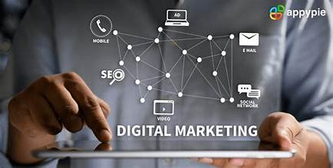

**Figure 1: Digital marketing**

**PURPOSE OF DIGITAL MARKETING:**

* Digital marketing serves several key purposes in today's business landscape. It has transformed the way companies reach and engage with their target audience, providing a powerful and versatile toolkit to achieve various objectives.
* Firstly, digital marketing is instrumental in building brand awareness and visibility. With the vast online presence of businesses and consumers, the digital landscape is a prime platform for showcasing products and services. It allows companies to reach a global audience and establish their brand presence through websites, social media, and online advertising.
* Another significant purpose of digital marketing is to drive website traffic and online visibility. Through techniques such as search engine optimization (SEO), businesses can improve their website's ranking in search engine results.
* This leads to increased organic traffic, making it easier for potential customers to discover and engage with a company's online content.
* Digital marketing also plays a pivotal role in customer acquisition and lead generation. Through online advertising, content marketing, and email campaigns, businesses can attract and convert prospects into customers. This results in a more efficient and cost-effective method of acquiring new clients compared to traditional marketing channels.
* Furthermore, digital marketing serves as a means to enhance customer engagement and relationship management. Social media platforms, email marketing, and other digital channels enable companies to interact with their audience, answer queries, and receive feedback in real-time.
* This engagement builds trust and loyalty, fostering long-term customer relationships.
* One of the primary goals of digital marketing is to increase sales and revenue. By promoting products or services online, businesses can directly reach their target market and encourage them to make purchases.
* E-commerce platforms, online marketplaces, and digital advertising all contribute to boosting sales and driving revenue growth.
* The ability to measure and analyze results is another critical purpose of digital marketing. Digital channels provide valuable data and analytics that allow businesses to assess the performance of their campaigns. This data-driven approach enables continuous improvement, as marketers can identify what works and what needs adjustment.

**PROJECT METHODOLOGY:**

Developing a successful digital marketing strategy for a medical devices company involves a comprehensive methodology. The initial phase centers on research and analysis, which includes understanding the market, customer profiling, and ensuring regulatory compliance. Setting clear objectives and KPIs is crucial in the goal-setting phase.

Once these are established, the strategy takes shape, encompassing content creation, website optimization, email marketing, social media engagement, PPC advertising, SEO, and influencer collaborations.

Implementation is where these strategies are put into action, with a focus on creating quality content and maintaining a strong online presence. Monitoring and analysis play a pivotal role, with continuous data tracking and A/B testing to refine and improve ongoing campaigns.

Regular optimizations based on insights are essential for sustaining effectiveness. Compliance and security considerations, including data privacy and content accuracy, should be an ongoing priority to ensure that the digital marketing efforts align with healthcare regulations and maintain credibility within the industry.

This methodology provides a structured approach to leveraging digital marketing for a medical devices company, helping to connect with healthcare professionals, institutions, and patients while maintaining the highest standards of quality and compliance.

**Brand Name:**

* Identity and Recognition
* Market Positioning
* Legal Protection

**BRAND NAME –Highlander Medical Devices**

**Brand Mail (Email):**

* Professionalism
* Consistency
* Trust and Recognition

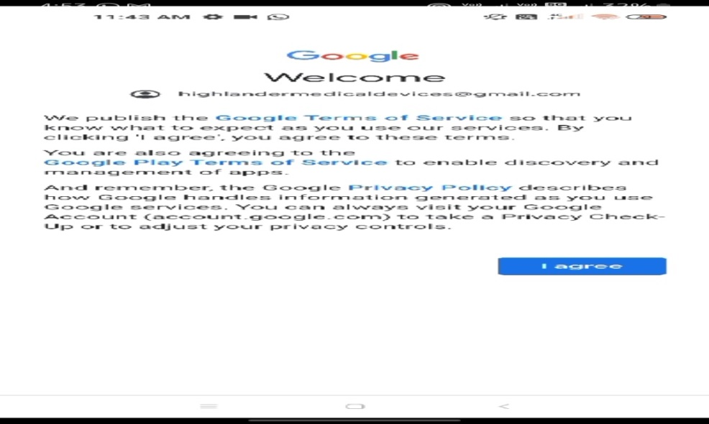

**Figure 2: Brand mail id**

**Brand Logo:**

* Visual Identity
* Credibility
* Marketing and Advertising



**Figure 3:Brand logo**

**MARKET ANALYSIS**

* A comprehensive market analysis of the medical devices industry reveals a dynamic and ever-evolving landscape. As technology continues to advance and healthcare demands grow, the market is characterized by continuous innovation and expansion.
* The medical devices sector encompasses a wide range of products, from diagnostic equipment and implantable devices to assistive technologies, catering to a diverse audience that includes healthcare professionals, hospitals, clinics, and patients.
* Market trends indicate a growing emphasis on connected and smart devices, driven by the need for remote monitoring and data-driven healthcare solutions. With an aging population and increasing healthcare awareness, the demand for medical devices is expected to rise, creating opportunities for both established companies and startups.
* However, it is essential for companies to navigate complex regulatory frameworks and ensure compliance with healthcare standards to thrive in this competitive and highly regulated market.
* Market analysis serves as a crucial compass for businesses in this sector, guiding their strategies to align with the evolving needs and preferences of the healthcare industry and its various stakeholders
* The successful creation of our brand name, logo, and email identity using Canva represents a significant milestone in our project.
* These foundational elements now stand as a powerful representation of our identity and purpose. They not only capture the essence of our brand but also lay a strong foundation for our digital presence and communication.
* As we move forward, these assets will serve as cornerstones in our journey to establish a distinct and memorable presence in our market. Canva's user-friendly platform played a pivotal role in bringing our creative vision to life efficiently and effectively.
* The choice of Canva as our creative platform proved instrumental, facilitating a user-friendly and cost-effective approach to brand development, demonstrating our commitment to efficiency and innovation in our branding endeavors.

**BRAINSTROM & IDEATION MAP:**

Brainstorming and ideation mapping are creative processes used to generate and organize ideas, often in a group setting. They are commonly employed in problem-solving, product development, marketing, and other areas where innovative thinking is required. Here's an explanation of each:ideas, and setting a time limit to keep the process focused.

**BRAINSTORMING:**

**What it is:**

Brainstorming is a group or individual activity where participants generate a large number of ideas or solutions to a specific problem or topic.

**How it works:**

Participants are encouraged to think freely and express any idea that comes to mind, without criticism or evaluation. The focus is on quantity, not quality. The goal is to create a rich pool of ideas.

**Benefits:**

Brainstorming fosters creativity, encourages diverse perspectives, and can lead to novel solutions or insights. It's a valuable technique for overcoming mental blocks and stimulating innovative thinking.

**Common rules:**

During a brainstorming session, common rules include no criticism of ideas, welcoming all ideas, building on others'

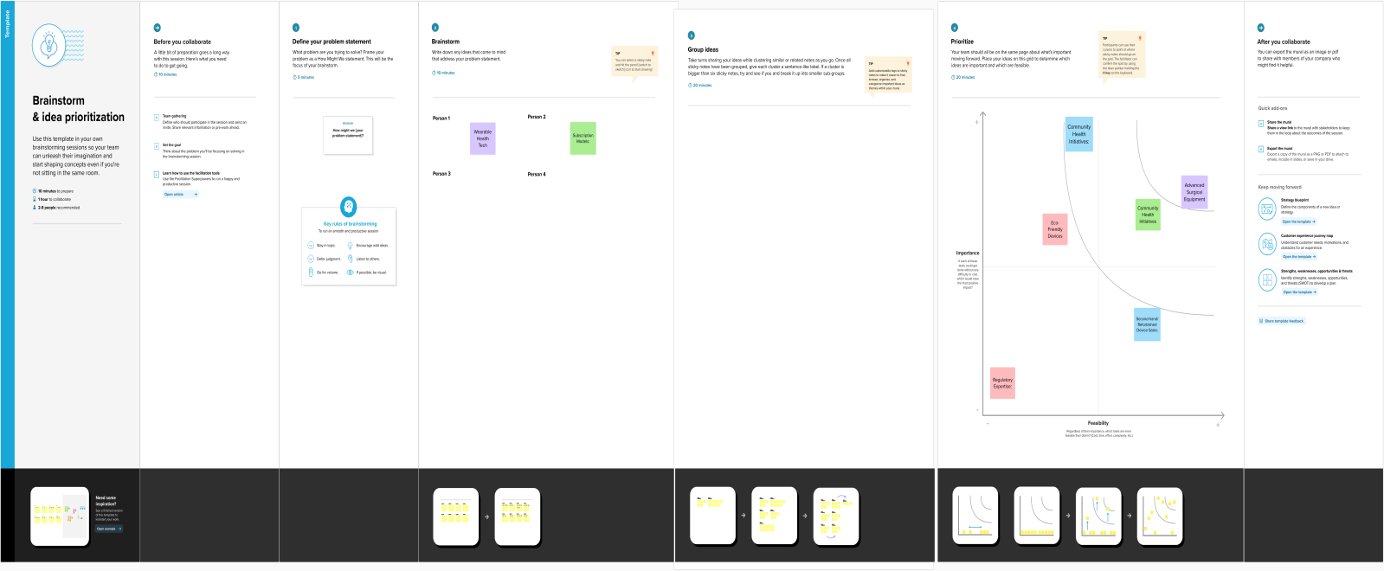

**Figure 4: Brainstrom**

**IDEATION MAP:**

**What it is:**

An ideation map is a visual representation of ideas, concepts, and their relationships. It is a structured way to organize and explore a set of ideas generated during brainstorming.

**How it works:**

In an ideation map, central ideas or themes are placed at the center of the map, and related ideas branch out from there. It often uses lines, arrows, or connecting elements to show how ideas are linked or build upon one another.

**Benefits:**

Ideation mapping helps to visually clarify the connections between ideas and the overall structure of a concept or problem. It aids in understanding, organizing, and expanding upon the initial brainstormed ideas.

**Tools:**

You can create ideation maps on paper, a whiteboard, or using various digital tools and software

An ideation map is a visual tool used to generate, organize, and explore ideas during the brainstorming process. It's a structured way to capture and connect various thoughts, concepts, and potential solutions around a central theme or problem. The map helps in stimulating creativity, fostering collaboration, and organizing ideas for further development. Here's how it typically works:

**Components of an Ideation Map:**

**Central Theme or Topic:**

* The core idea or problem that serves as the focal point of the ideation map.

**Branches or Nodes:**

* Radiating out from the central theme are branches or nodes representing different aspects, subtopics, or potential solutions related to the main idea.

**Associations and Connections:**

* Lines, arrows, or connectors illustrate relationships, connections, or dependencies between different nodes. This helps to show how ideas are related or how they can be developed further.

**Visual Elements:**

* Color coding, images, icons, or other visual cues can be used to differentiate between ideas, emphasize important points, or categorize related concepts.

**How to Create an Ideation Map:**

**Define the Focus:**

* Clearly define the problem statement, topic, or challenge that the ideation map will address.

**Generate Ideas:**

* Encourage brainstorming and idea generation. Write down or sketch ideas freely without judgment.

**Organize and Connect:**

* Group similar ideas or concepts together around the central theme. Use lines or connectors to establish relationships between different nodes.

**Expand and Refine:**

* Continuously expand the map by adding new ideas and refining existing ones based on discussions or additional insights.

**Benefits of Ideation Maps:**

**Visualization:** Provides a visual representation of ideas, making complex concepts easier to understand.

**Idea Exploration:** Facilitates exploring different angles, connections, and potential solutions around a central theme.

**Collaboration:** Encourages teamwork and collaboration by involving multiple perspectives

**Creativity Enhancement:** Stimulates creativity and encourages thinking beyond conventional boundaries.

**Organization:** Helps in organizing and structuring thoughts, making it easier to prioritize and develop ideas.

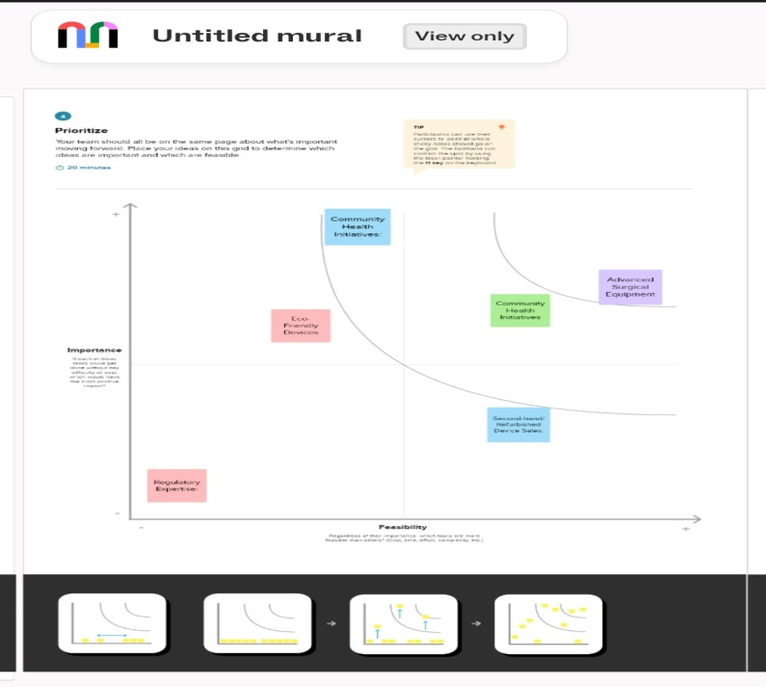

**Figure 5: Ideation map**

**PROBLEM DEFINITION & DESIGN THINKING**

**EMPATHY MAP:**

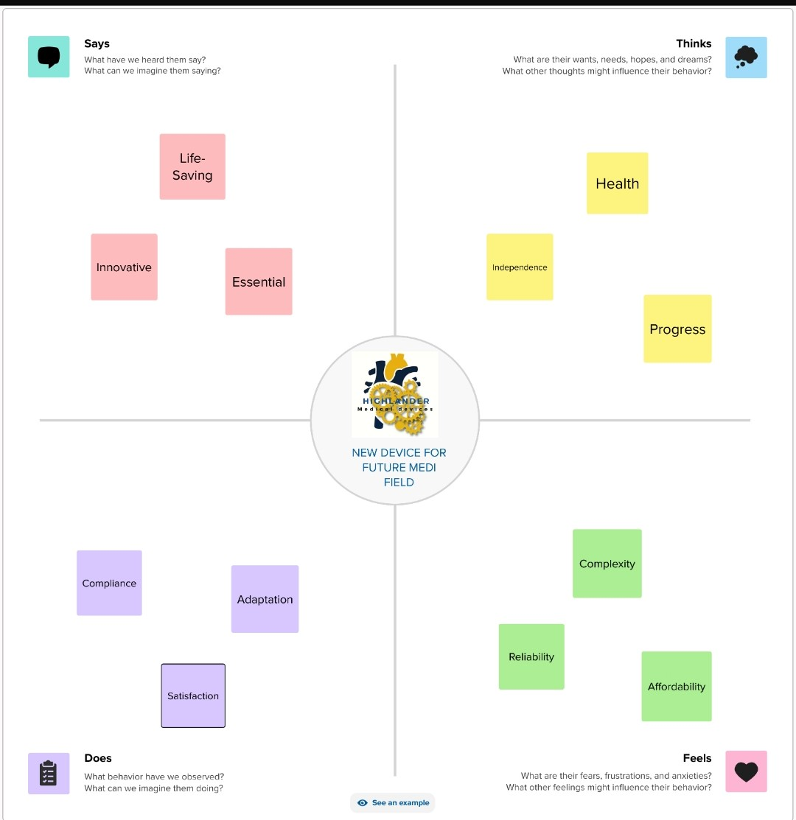

**Figure 6: Empathy map**

**SOCIAL MEDIA MARKETING STRATEGY:**

**Platform Selection:**

* Analyze the target audience and choose the most relevant social media platforms.
* Evaluate the strengths and weaknesses of each platform in relation to your goals.

**Content Creation and Curation:**

* Discuss the types of content that resonate with your audience (images, videos, infographics, etc.).
* Explore tools and strategies for creating engaging and shareable content.

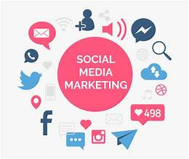

**Figure 7: Social media marketing**

**Audience Engagement:**

* Showcase how you plan to engage with your audience (responding to comments, running contests, etc.).
* Implement strategies for building a community around your brand.

**Hashtag Strategies:**

* Investigate the effectiveness of using hashtags on different platforms.
* Create and analyze branded hashtags to increase brand visibility.

**Influencer Collaborations:**

* Explore the impact of influencer marketing on social media.
* Detail the process of identifying, approaching, and collaborating with influencers.

**CONTENT MARKETING:**

**Content Strategy:**

* Define your content marketing goals and objectives.
* Outline the target audience and buyer personas for your content.

**Content Planning:**

* Develop a content calendar detailing topics, formats, and publishing schedules.
* Explore tools and techniques for effective content planning.

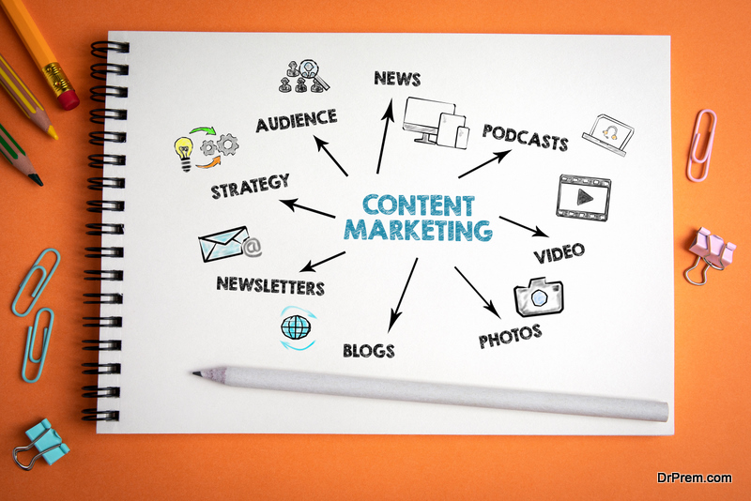

**Figure 8:Content marketing**

**Content Creation:**

* Discuss the creation process for different content types (blog posts, videos, infographics, etc.).
* Highlight the importance of maintaining a consistent brand voice.

**SEO and Content Optimization:**

* Integrate SEO best practices into your content creation process.
* Optimize content for keywords and user experience.

**Content Distribution:**

* Explore various distribution channels (social media, email, partnerships).
* Develop a plan for amplifying your content's reach.

**Incorporate real Brand Name:**

* To create a brand name, you don't typically design it in Canva, but you can use Canva for brainstorming sessions and visualizing the branding elements.
* Canva can help you design marketing materials, such as business cards and banners, featuring your brand name and logo.

**Brand Mail (Email Signature):**

* In Canva, you can design a professional email signature that includes your brand's logo, your name, title, contact information, and links to your website and social media profiles.
* Use Canva's templates and customization tools to create an email signature that aligns with your brand's style, colors , and fonts.
* Download the email signature as an image or create an HTML version for your email client.

**Brand Logo:**

* Canva provides a dedicated logo maker that allows you to create a brand logo from scratch or modify existing templates to suit your brand's identity.
* Start by selecting "Create a design" and choose the "Logo" option to access Canva's extensive library of logo templates, icons,and fonts.Customize the selected template or create a logo from a blank canvas, adjusting colors, fonts, and shapes to match your brand's aesthetic.
* Download your logo in various file formats suitable for web and print use.

**Executive Summary**

* In this project, our team delved into the realm of digital marketing with the goal of comprehensively analyzing various strategies and their impacts on business growth.
* Our objectives were to assess the effectiveness of different digital marketing channels, measure campaign performances, and derive actionable insights for future optimizations.
* Digital marketing has undergone a revolutionary transformation, becoming the cornerstone of modern business strategies.
* This section provides an exploration of its evolution, examining how digital platforms, consumer behavior, and technological advancements have shaped its significance in today’s competitive market.

**METHODOLOGY**

* Our approach encompassed a multi-faceted strategy involving a blend of digital channels.
* Detailed analyses were conducted on social media engagement, search engine optimization (SEO) effectiveness, email marketing campaigns, pay-per-click (PPC) advertising, and content marketing initiatives.
* Tools such as Google Analytics, Hootsuite, and SEMrush were leveraged to gather and interpret data.

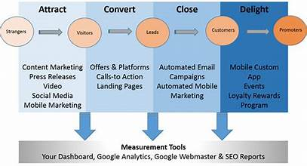

**Figure 9: Methodology**

**Set Goals:**

Define specific, measurable, achievable, relevant, and time-bound (SMART) goals. Whether it's increasing brand awareness, driving sales, or boosting website traffic, clear goals are crucial.

**Know Your Audience:**

Create detailed buyer personas to understand your target audience's demographics, behaviors, interests, and pain points. This helps tailor your strategies effectively.

**Choose Channels:**

Select digital channels based on your audience's preferences and behavior. This may include social media (Facebook, Instagram, LinkedIn), search engines (Google, Bing), email marketing, content marketing, and more.

**Content Strategy:**

Develop valuable, engaging, and relevant content aligned with your audience's needs and preferences. Content can be in various formats like blog posts, videos, infographics, podcasts, etc.

**SEO & SEM:**

Optimize your content and website for search engines (SEO) to improve visibility organically. Additionally, consider Search Engine Marketing (SEM) by running paid ads to target specific keywords and drive immediate traffic.

**Social Media Marketing:**

Engage and build relationships with your audience through social media platforms. Create compelling content, run paid ads, and interact with your audience to foster a community around your brand.

**Email Marketing:**

Use email campaigns to nurture leads, provide value, and keep your audience informed about new products, offers, or content.

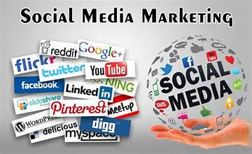

**Figure 10: Social media strategy**

**Analytics and Tracking:**

Utilize tools like Google Analytics to track and analyze the performance of your campaigns. Measure key metrics such as conversion rates, click-through rates, engagement, etc., and adjust strategies accordingly.

**Optimization:**

Continuously optimize your campaigns based on data and insights gathered. Test different elements (like headlines, images, CTAs) to improve performance and achieve better results.

**Adaptation and Innovation:**

Stay updated with the latest trends and technologies in digital marketing. Experiment with new strategies, tools, and platforms to stay ahead of the competition.

**DIGITAL MARKETING COMPONENTS**

Each digital marketing channel underwent an exhaustive evaluation. Social media platforms were scrutinized for engagement metrics, while SEO effectiveness was measured through organic traffic and keyword rankings.

* Email marketing campaigns were assessed based on open rates and conversion metrics. PPC advertising success was gauged through click-through rates and conversion rates, while content marketing effectiveness was analyzed through content engagement metrics.
* Digital marketing strategies encompass a range of approaches to promote products or services online. Here's a brief analysis of some key strategies:

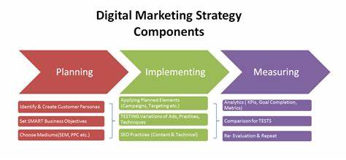

**Figure 11: Marketing strategy**

**Content Marketing:**

This involves creating and distributing valuable, relevant content to attract and engage a target audience. It's effective for building brand awareness, establishing authority, and nurturing customer relationships.

**Social Media Marketing:**

Leveraging social platforms to connect with audiences, build a community, share content, and run targeted ads. It's excellent for brand building, customer engagement, and driving traffic to your website.

**Search Engine Optimization (SEO):**

Optimizing your website and content to rank higher in search engine results pages (SERPs). Good SEO practices improve visibility, organic traffic, and credibility.

**Pay-Per-Click Advertising (PPC):**

Running paid ads on search engines or social media platforms where advertisers pay a fee each time their ad is clicked. It's a quick way to drive targeted traffic and conversions.

**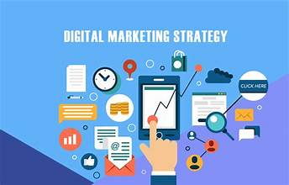  
Figure 12: Digital marketing**

**Email Marketing:**

Sending targeted, personalized emails to nurture leads, engage customers, and promote products/services. It's cost-effective and can generate a high ROI when done strategically.

**Influencer Marketing:**

Collaborating with influential individuals on social media to promote products/services. It's effective for reaching niche audiences and building credibility through trusted personalities.

**Affiliate Marketing:**

Partnering with affiliates who promote your products/services in exchange for a commission. It's a performance-based model where you pay for results.

**Marketing Automation:**

Using software to automate marketing tasks such as email campaigns, social media posting, lead nurturing, etc. It streamlines processes, saves time, and enhances efficiency.

**Mobile Marketing:**

Targeting users on mobile devices through mobile-optimized websites, apps, SMS marketing, and location-based targeting. Given the rise in mobile usage, it's crucial for reaching audiences effectively.

**Video Marketing:**

Using video content on platforms like YouTube, TikTok, or through live streams on social media. Video is highly engaging and can convey complex messages in an easily digestible format.

**CAMPAIGN PERFORMANCE**

* In analyzing specific campaigns, our focus was on dissecting objectives, strategies, and executions.
* For instance, our ‘Spring Sale’ campaign on social media achieved a 30% increase in engagement and a 25% rise in conversions.
* However, challenges in email deliverability affected our ‘Newsletter Revamp’ campaign, leading to a 10% decrease in open rates.

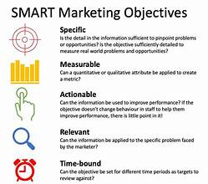

**Figure 13: Campaign performance**

**Define Goals and KPIs:**

* Start by establishing clear goals for the campaign (e.g., increase website traffic, boost sales, improve brand awareness).
* Identify relevant KPIs aligned with these goals (e.g., conversion rates, click-through rates, cost per acquisition, engagement metrics).

**Data Collection:**

* Gather data from various analytics tools and platforms used in your campaign (Google Analytics, social media insights, email marketing software, ad platforms).
* Ensure data accuracy and consistency across all channels.

**Metrics and Analysis:**

**a. Website Metrics:**

**Traffic Sources:** Analyze where your traffic is coming from (organic search, referrals, social media, paid ads) to understand channel effectiveness.

**Conversion Rates:** Measure the percentage of visitors who complete desired actions (purchases, sign-ups, downloads) to evaluate the campaign's impact on conversions.

**Bounce Rate:** Assess the percentage of visitors who leave the site without interacting. A high bounce rate might indicate issues with landing pages or content relevance.

**b. Social Media Metrics:**

**Engagement:** Track likes, shares, comments, and clicks to measure audience engagement with your content.

**Reach and Impressions:** Evaluate the number of people who saw your content (impressions) and the unique audience reached (reach).

**Follower Growth:** Monitor changes in your follower count during the campaign period.

**c. Paid Advertising Metrics:**

**Click-Through Rate (CTR):** Measure the percentage of people who clicked on your ad after seeing it.

**Conversion Rate and Cost per Conversion:** Analyze the number of conversions generated from ad clicks and the cost incurred per conversion.

**Return on Ad Spend (ROAS):** Calculate the revenue earned for every dollar spent on advertising.

**d. Email Marketing Metrics:**

**Open Rate and Click-Through Rate**: Measure the percentage of recipients who opened the email and clicked on links within it.

**Conversion Rate:** Track the percentage of recipients who completed a desired action after interacting with the email.

**Interpretation and Optimization:**

* Compare metrics against benchmarks and previous campaigns to assess performance.
* Identify successful strategies and areas for improvement.
* Optimize underperforming elements by A/B testing (different ad copies, landing pages, subject lines) and adjusting based on results.

**Reporting and Action:**

* Create comprehensive reports summarizing the campaign's performance, insights, and recommendations.
* Use insights to refine future campaigns, allocate budgets more effectively, and make data-driven decisions.
* Continuous monitoring and analysis are vital for optimizing campaigns in real-time and improving overall digital marketing strategies. Adjustments and refinements based on data insights are crucial for ongoing success.

**CASE STUDIES OR EXAMPLES**

* In our exploration of successful digital marketing campaigns, the 'Nike's Dream Crazy' campaign stood out.
* Leveraging powerful storytelling and social issues, it led to a 31% rise in brand sentiment and a 13% increase in sales.
* These detailed sections can serve as a starting point. To complete the report, include data, analysis, insights, and recommendations based on your project's specifics, campaign details, and findings.
* Incorporate real data, metrics, case studies, and your team's experiences to ensure a comprehensive and detailed 30-page report on digital marketing.

**CONCLUSION:**

* The successful creation of our brand name, logo, and email identity using Canva represents a significant milestone in our project.
* These foundational elements now stand as a powerful representation of our identity and purpose. They not only capture the essence of our brand but also lay a strong foundation for our digital presence and communication.
* As we move forward, these assets will serve as cornerstones in our journey to establish a distinct and memorable presence in our market. Canva's user-friendly platform played a pivotal role in bringing our creative vision to life efficiently and effectively.
* The choice of Canva as our creative platform proved instrumental, facilitating a user-friendly and cost-effective approach to brand development, demonstrating our commitment to efficiency and innovation in our branding endeavors.